**Q. Write a program to check whether number is even or odd.**

**Coding:**

import java.lang.*;

class even

{

public static void main(String a[])

{

int n;

n=11;

if(n%2==0)

System.out.println(n+" is even.");

else

System.out.println(n+" is odd.");

}

};

**Output:**

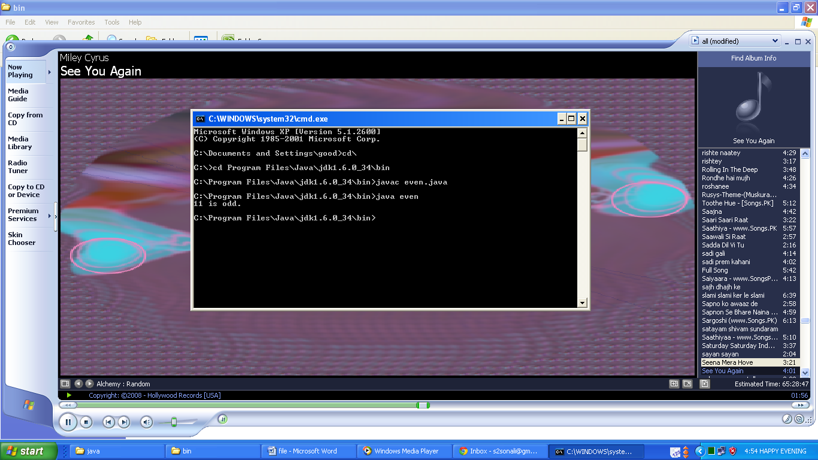

**Q. Write a program to find average of three numbers.**

**Coding:**

import java.lang.*;

class avg

{

public static void main(String ar[])

{

int a,b,c,d;

a=5;

b=6;

c=7;

d=(a+b+c)/3;

System.out.println("Average = "+d);

}

};

**Output:**

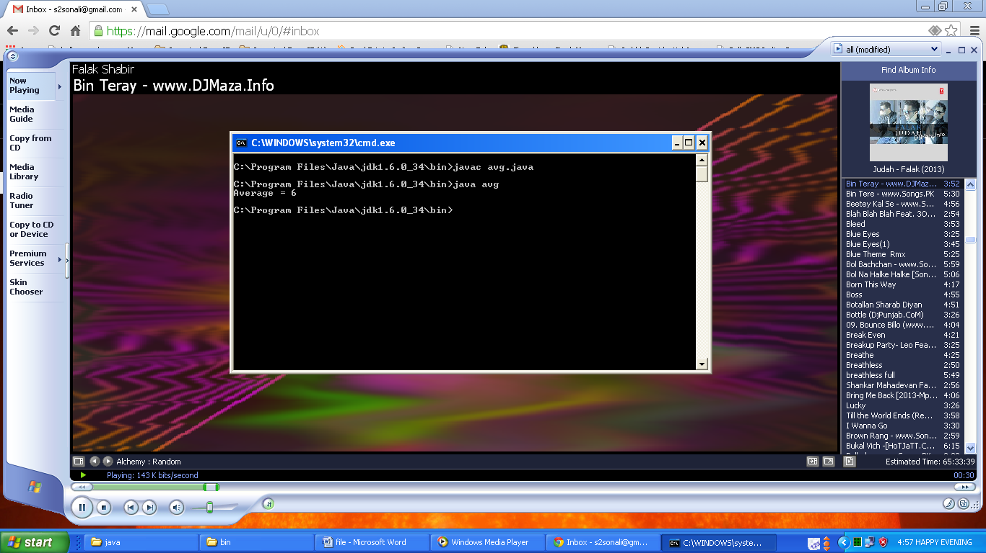

**Q. Write a program to calculate addition, subtraction, multiplication and division of two numbers.**

**Coding:**

import java.lang.*;

class arith

{

public static void main(String ar[])

{

int a,b,c;

a=6;

b=3;

c=a+b;

System.out.println("Sum = "+c);

c=a-b;

System.out.println("Difference = "+c);

c=a*b;

System.out.println("Product = "+c);

c=a/b;

System.out.println("Quotient = "+c);

}

};

**Output:**

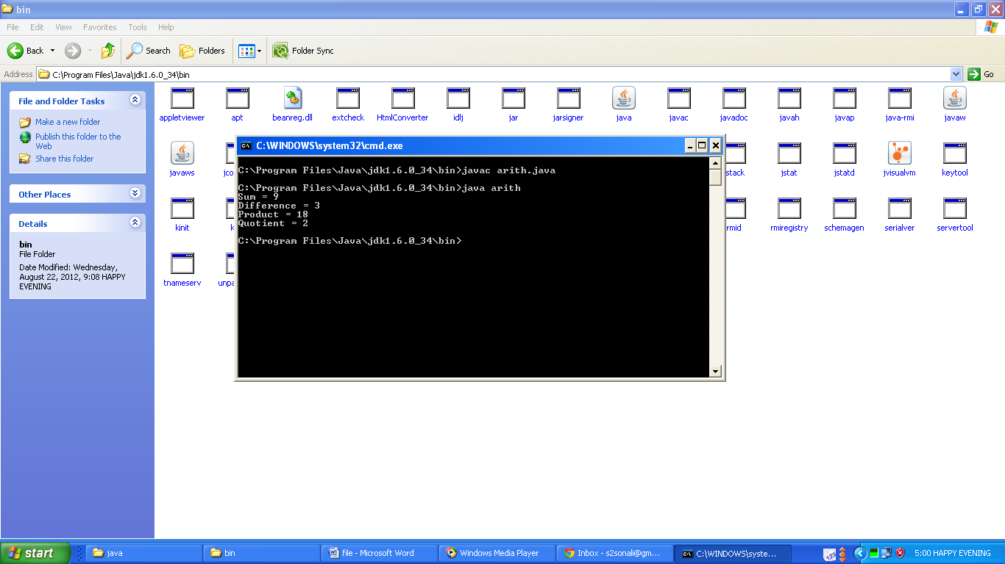

**Q. Write a program to find area of circle, rectangle and triangle.**

**Coding:**

import java.lang.*;

class area

{ public static void main(String ar[])

{ int r,x,y;

double a;

x=50;

y=60;

a=x*y;

System.out.println("Area of Rectangle with length "+x+" and breadth "+y+" is "+a);

r=50;

a=3.14*r*r;

System.out.println("Area of Circle with radius "+r+" is "+a);

x=20;

y=50;

a=0.5*x*y;

System.out.println("Area of Triangle with base "+x+" and height "+y+" is "+a);

}

};

**Output:**

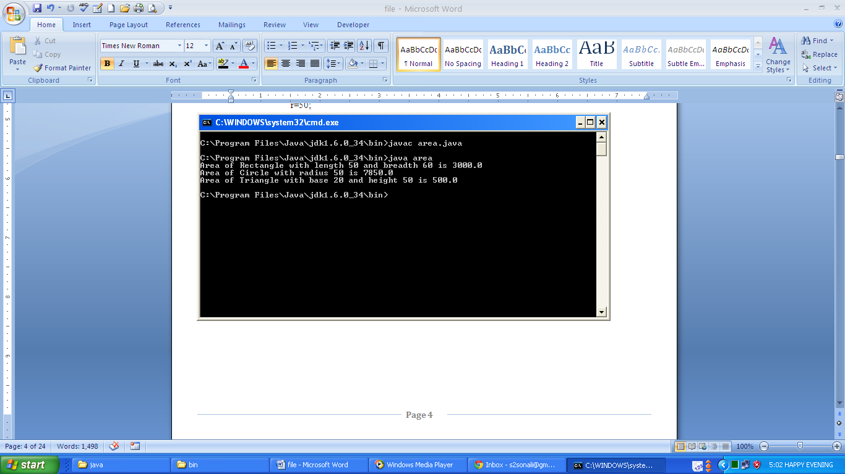

**Q. Write a program to swap two numbers using third variable.**

**Coding:**

import java.lang.*;

class swap

{

public static void main(String ar[])

{

int a,b,c;

a=3;

b=2;

System.out.println("Before Swaping:\na = "+a+", b = "+b);

c=a;

a=b;

b=c;

System.out.println("After Swaping:\na = "+a+", b = "+b);

}

};

**Output:**

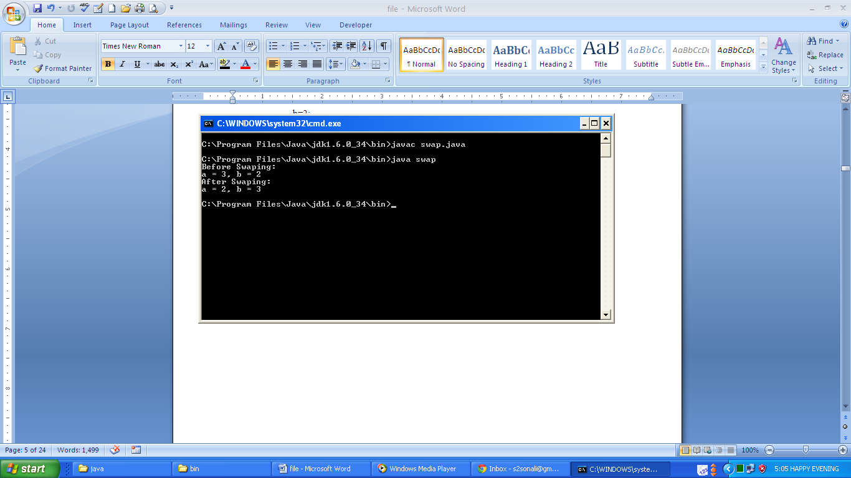

**Q. Write a program to print numbers from 1 to 50.**

**Coding:**

import java.lang.*;

class nos

{

public static void main(String ar[])

{

for(int i=1;i<=50;i++)

System.out.println(i);

}

};

**Output:**

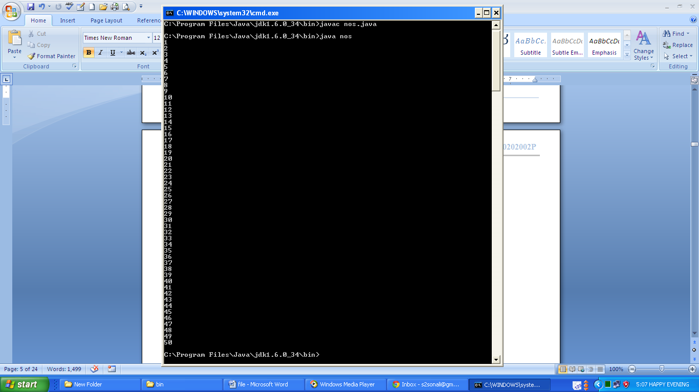

**Q. Write a program to print largest of three numbers.**

**Coding:**

import java.lang.*;

class greatest

{

public static void main(String ar[])

{

int a,b,c;

a=3;

b=4;

c=5;

if(a>b && a>c)

System.out.println("a is greatest.");

else if(b>a && b>c)

System.out.println("b is greatest");

else

System.out.println("c is greatest.");

}

};

**Output:**

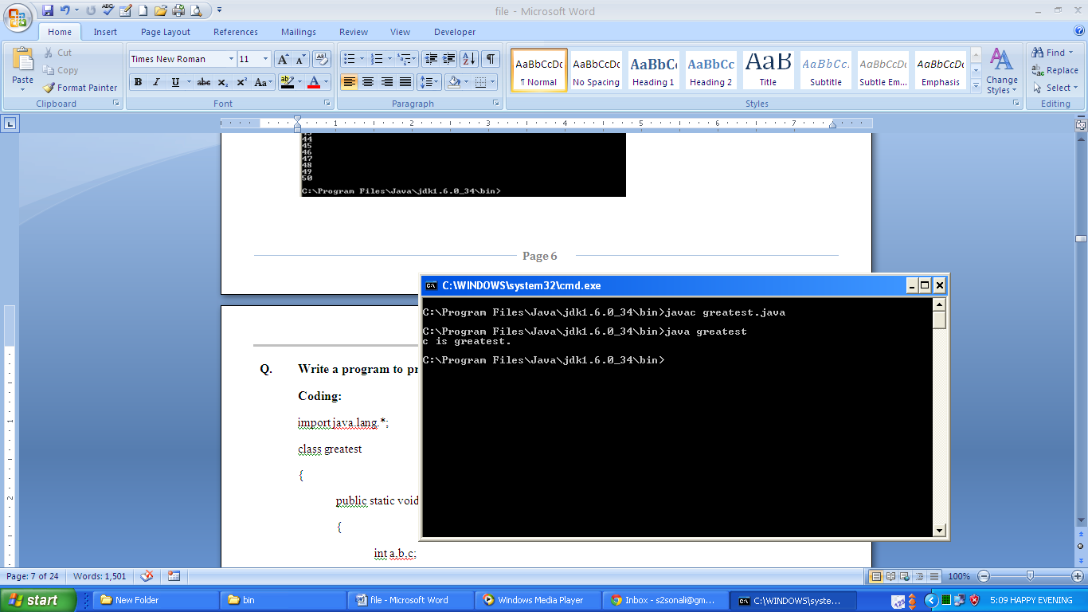

**Q. Write a program to print reverse of the number.**

**Coding:**

import java.lang.*;

class reverse

{

public static void main(String ar[])

{

int n,r,p,m;

n=321;

r=0;

m=n;

while(m!=0)

{

p=m%10;

r=(r*10)+p;

m=m/10;

}

System.out.println("Reverse of "+n+" is "+r);

}

};

**Output:**

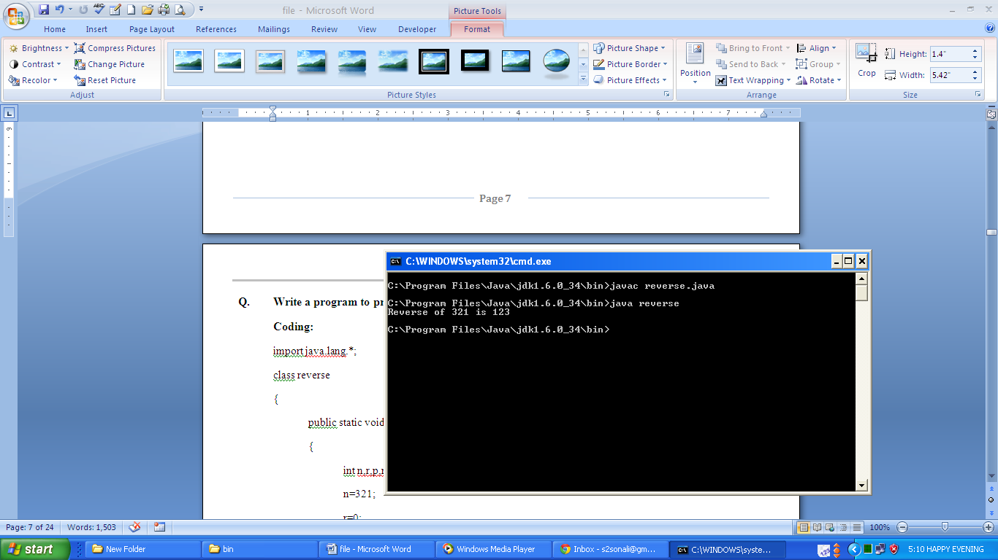

**Q. Write a program to check whether number is palindrome or not.**

**Coding:**

import java.lang.*;

class pali

{ public static void main(String ar[])

{ int n,r,p,m;

n=121;

r=0;

m=n;

while(m!=0)

{ p=m%10;

r=(r*10)+p;

m=m/10;

}

if(n==r)

System.out.println(n+" is palindrome.");

else

System.out.println(n+" is not palindrome.");

}

};

**Output:**

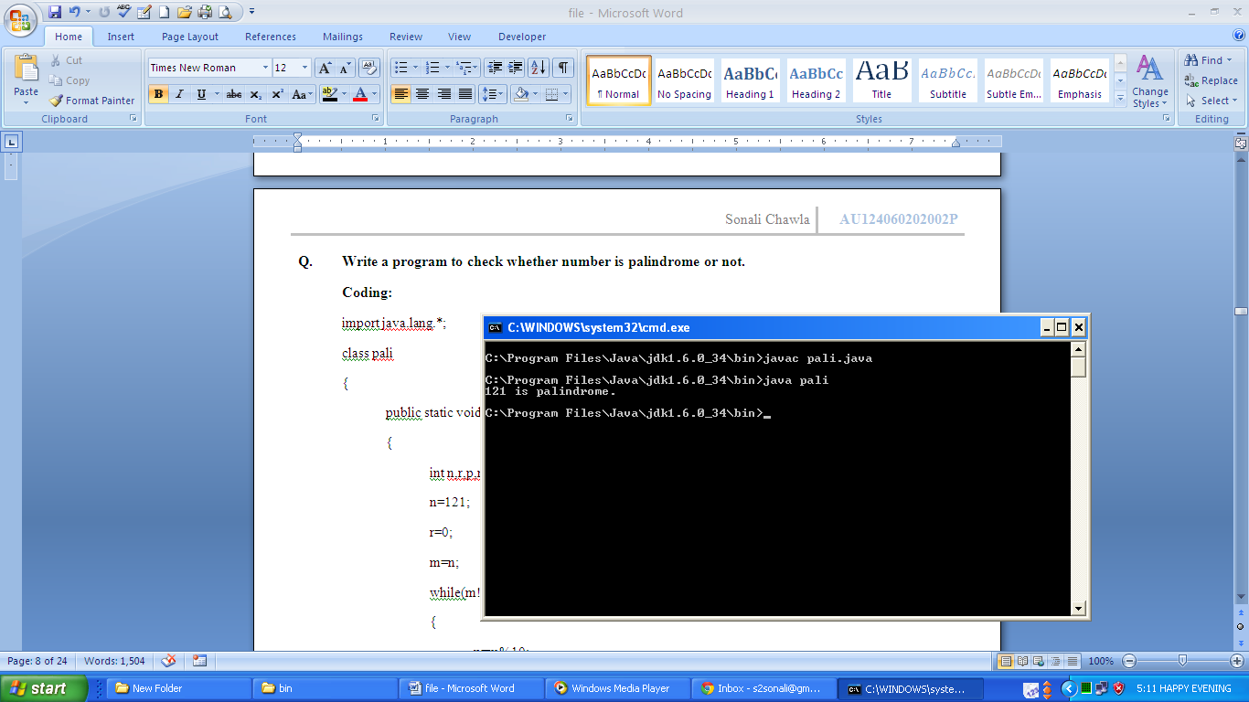

**Q. Write a program to check whether number is Armstrong or not.**

**Coding:**

import java.lang.*;

class ams

{ public static void main(String ar[])

{ int n,r,p,m;

n=371;

r=0;

m=n;

while(m!=0)

{ p=m%10;

r=r+(p*p*p);

m=m/10;

}

if(n==r)

System.out.println(n+" is amstrong.");

else

System.out.println(n+" is not amstrong.");

}

};

**Output:**

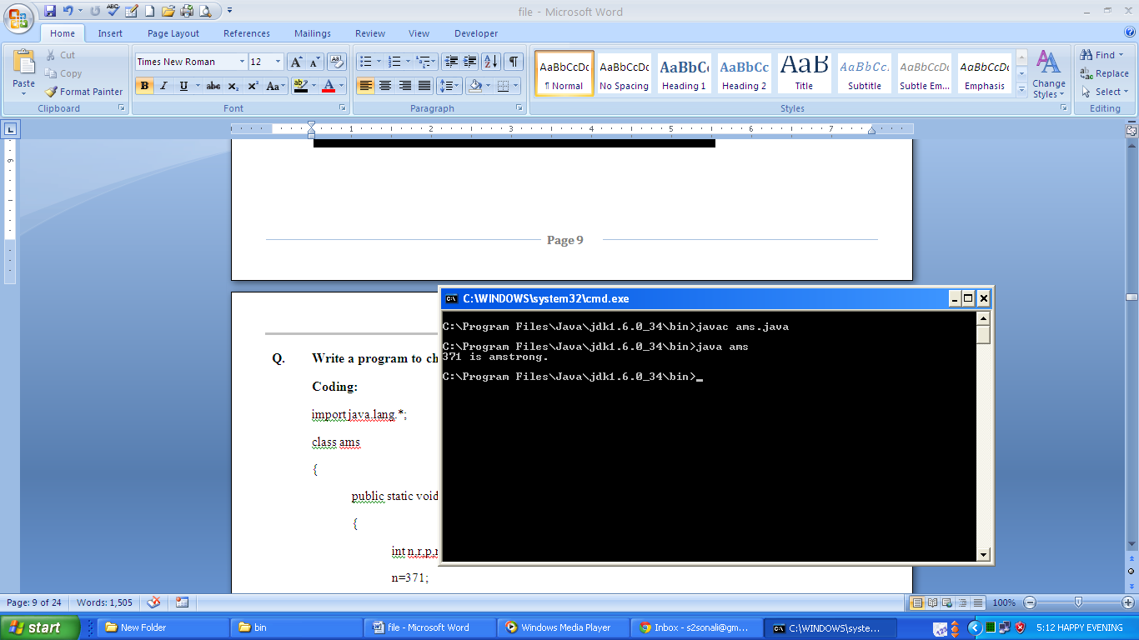

**Q. Write a program to create, print and manipulate one dimensional and two dimensional arrays.**

**Coding:**

import java.lang.*;

class arr

{

public static void main(String ar[])

{

int a[]={10,20,30};

int b[][]={{1,2},{3,4}};

System.out.println("Original Array A:");

for(int i=0;i<3;i++)

{

System.out.println(" element "+(i+1)+": "+a[i]);

a[i]=a[i]+5;

}

System.out.println("\nModified Array A:");

for(int i=0;i<3;i++)

{

System.out.println(" element "+(i+1)+": "+a[i]);

}

System.out.println("Original Array B:");

for(int i=0;i<2;i++)

{

for(int j=0;j<2;j++)

System.out.print(b[i][j]+"\t");

System.out.println();

}

for(int i=0;i<2;i++)

{

for(int j=0;j<2;j++)

b[i][j]=b[i][j]+1;

System.out.println();

}

System.out.println("Modified Array B:");

for(int i=0;i<2;i++)

{

for(int j=0;j<2;j++)

System.out.print(b[i][j]+"\t");

System.out.println();

}

}

};

**Output:**

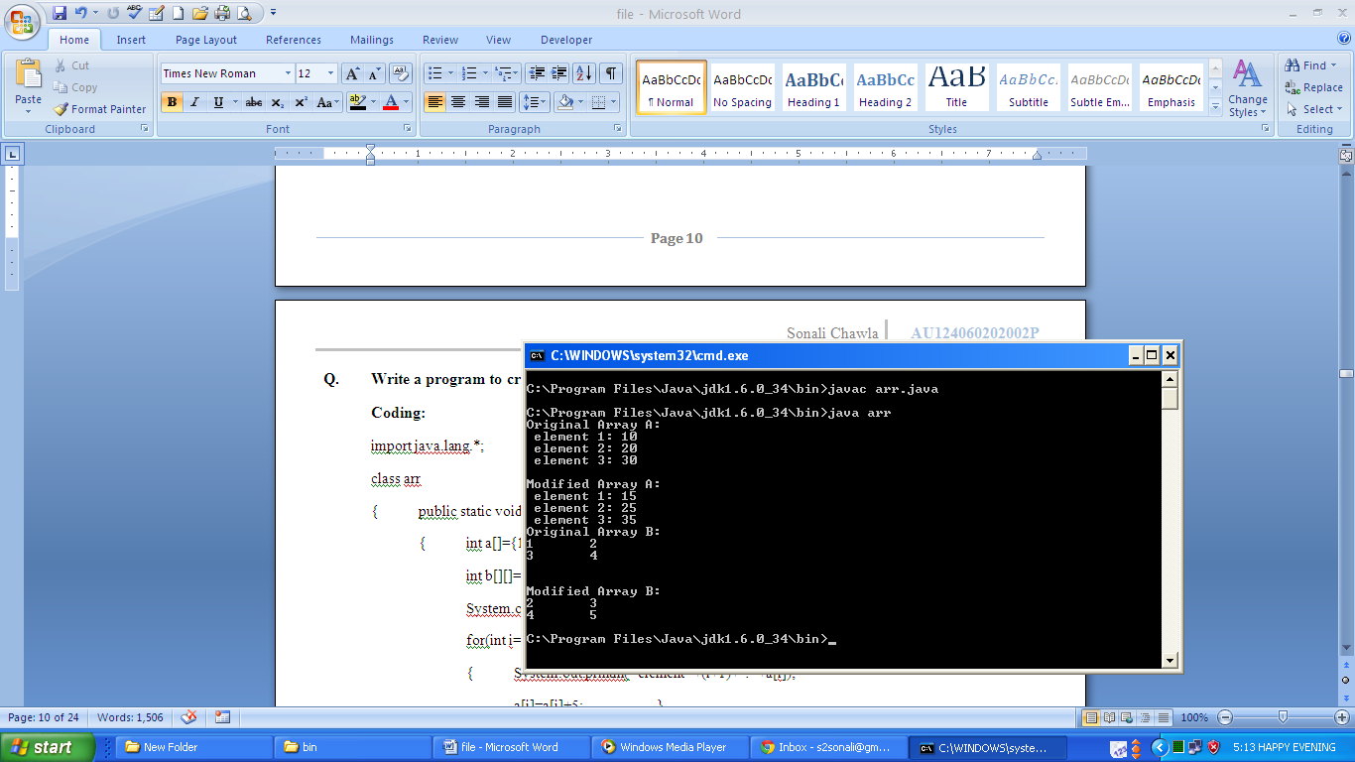

**Q. Write a program to create class box and find its volume. Use methods to find the volume and setting data for data variable.**

**Coding:**

import java.lang.*;

class box

{ int l,b,h;

void setdata(int x, int y, int z)

{ l=x;

b=y;

h=z; }

void vol()

{ int v;

v=l*b*h;

System.out.println("Volume: "+v); }

};

class volume

{ public static void main(String ar[])

{ box b1=new box();

b1.setdata(20,30,40);

b1.vol(); }

};

**Output:**

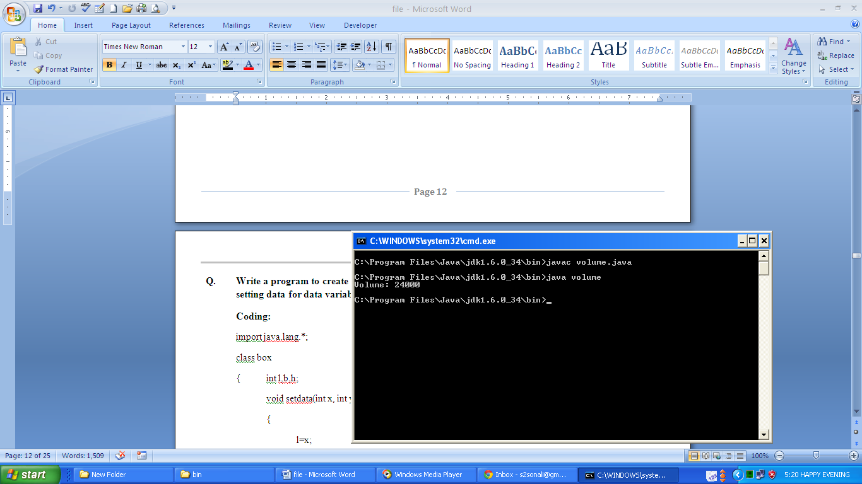

**Q. Write a program to create class rectangle and calculate its area. Use default and parameterized constructor to initialize data members.**

**Coding:**

import java.lang.*;

class rectangle

{ int l,b;

rectangle(int x, int y)

{ l=x;

b=y; }

rectangle()

{ l=b=10; }

void calc()

{ int a;

a=l*b;

System.out.println("Area: "+a); }

};

class area

{ public static void main(String ar[])

{ rectangle r1=new rectangle();

rectangle r2=new rectangle(20,30);

r1.calc();

r2.calc(); }

};

**Output:**

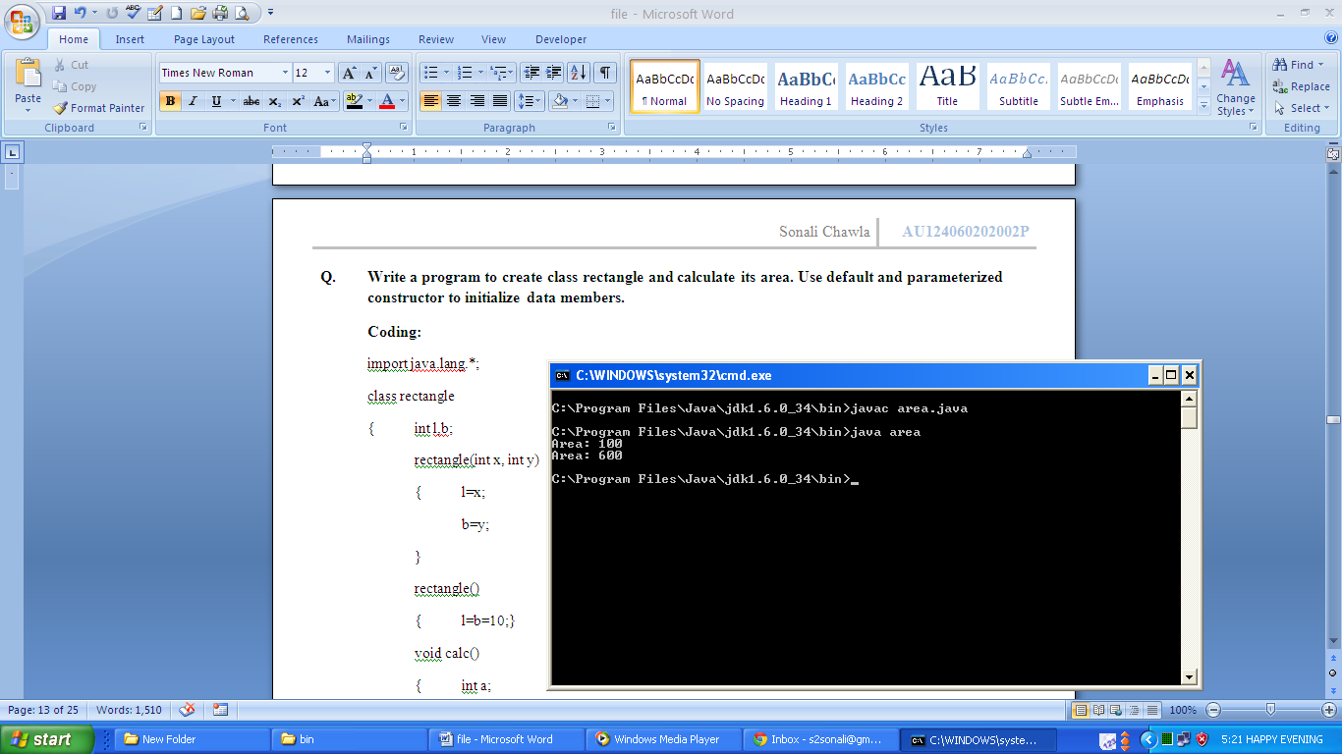

**Q. Write a program to create a multi-dimensional array which have four rows where first row consists of one element, second row consists of two elements, third row consists of three elements and fourth row consists of four elements to give the output as mentioned:**

**0**

1. **2**

**3 4 5**

**6 7 8 9**

**Coding:**

import java.lang.*;

class array

{ public static void main(String ar[])

{ int a[][]=new int[4][];

a[0]=new int[1]; a[1]=new int[2];

a[2]=new int[3]; a[3]=new int[4];

int k=0;

for(int i=0;i<4;i++)

{ for(int j=0;j<=i;j++)

{ System.out.print(k+"\t");

k++; }

System.out.println("\n");

} }

};

**Output:**

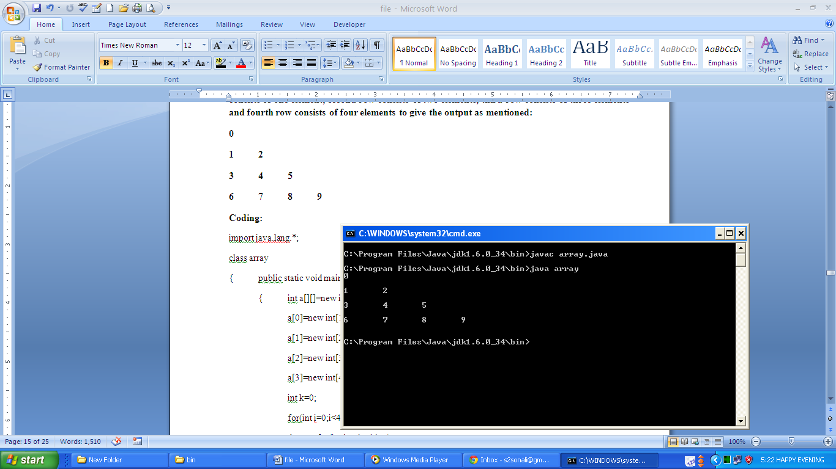

**Q. Write a program to create a 3 X 3 matrix and perform matrix addition, subtraction and multiplication.**

**Coding:**

import java.lang.*;

class matrix

{ public static void main(String ar[])

{ int a[][]=new int[3][3];int b[][]=new int[3][3];int c[][]=new int[3][3];

a[0][0]=1;a[0][1]=2;a[0][2]=3;

a[1][0]=4;a[1][1]=5;a[1][2]=6;

a[2][0]=7;a[2][1]=8;a[2][2]=9;

b[0][0]=0;b[0][1]=1;b[0][2]=2;

b[1][0]=3;b[1][1]=4;b[1][2]=5;

b[2][0]=6;b[2][1]=7;b[2][2]=8;

System.out.println("Addition of matrix a and b");

for(int i=0;i<3;i++)

{

for(int j=0;j<3;j++)

{

c[i][j]=a[i][j]+b[i][j];

System.out.print(c[i][j]+"\t");

}

System.out.println();

}

System.out.println("Subtraction of matrix a and b");

for(int i=0;i<3;i++)

{

for(int j=0;j<3;j++)

{

c[i][j]=a[i][j]-b[i][j];

System.out.print(c[i][j]+"\t");

}

System.out.println();

}

System.out.println("Multiplication of matrix a and b");

for(int i=0;i<3;i++)

{

for(int j=0;j<3;j++)

{

c[i][j]=0;

for(int k=0;k<3;k++)

c[i][j]=c[i][j]+a[i][k]*b[k][j];

System.out.print(c[i][j]+"\t");

}

System.out.println();

}

}

};

**Output:**

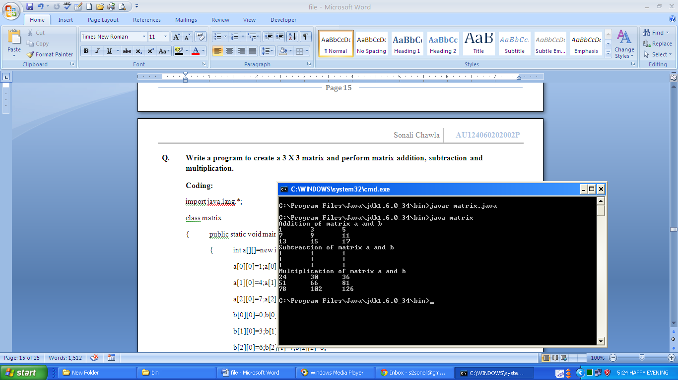

**Q. Write a program to implement stacks using arrays and to implement push and pop operations.**

**Coding:**

import java.lang.*;

class calc

{ int a[]=new int[3]; int top;

calc()

{ top=-1; }

void push(int i)

{ ++top;

a[top]=i; }

void pop()

{ System.out.println("Element Deleted: "+a[top]);

top--; }

};

class stack

{ public static void main(String arg[])

{ calc c1=new calc();

for(int i=0;i<3;i++)

c1.push(i);

for(int i=0;i<3;i++)

c1.pop();

}

};

**Output:**

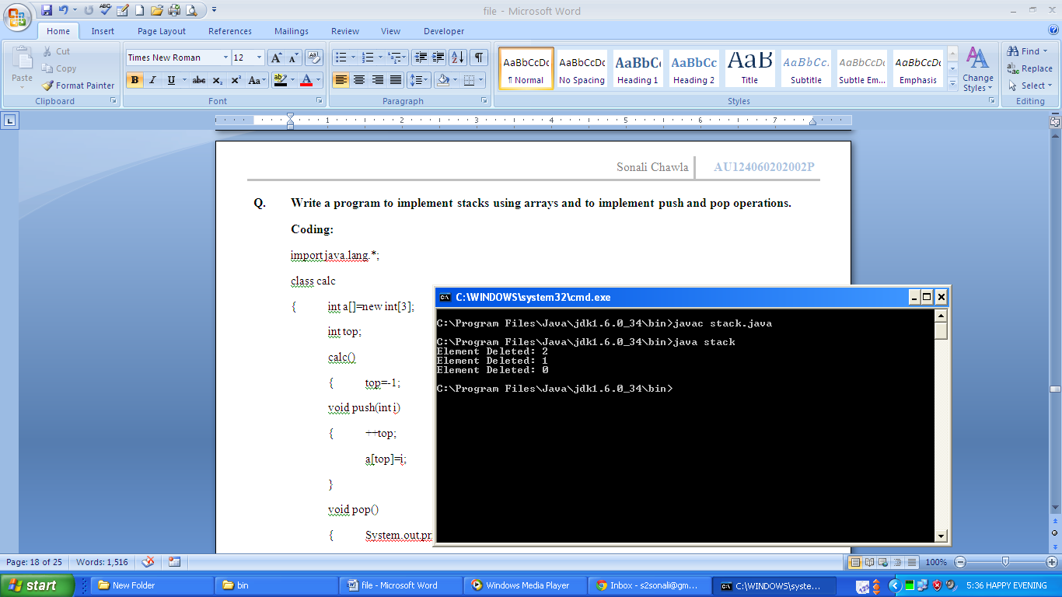

**Q. Write a program to find factorial of a given number using recursion.**

**Coding:**

import java.lang.*;

class cal

{ int calc(int x)

{ if(x==1)

return x;

else

{ int f=x*calc(x-1);

return f;

}

}

};

class fact

{ public static void main(String ar[])

{ cal c1=new cal();

int n=4,f;

f=c1.calc(n);

System.out.println("Factorial:"+f);

}

};

**Output:**

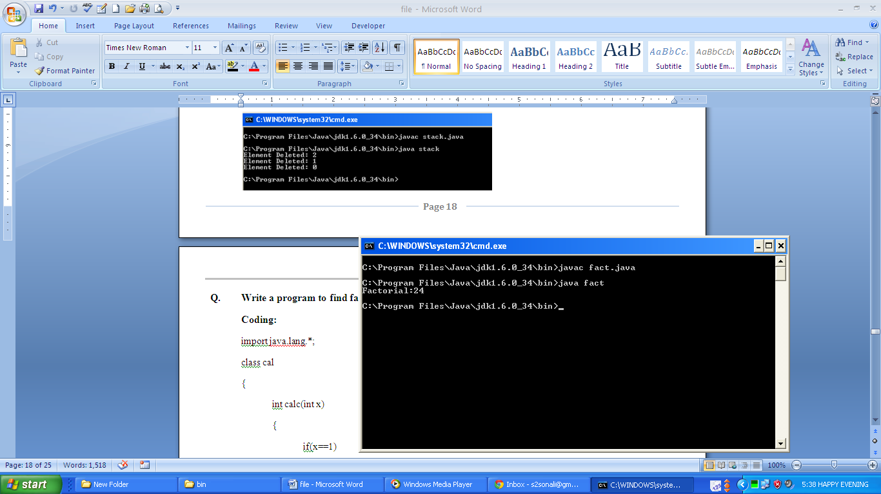

**Q. Write a program to create a class and make use of constructor overloading and method overloading by following the instructions:**

* **There should be three function:**
  + **area() for calculating area of a circle**
  + **area(int a) for calculating area of a square**
  + **area(int a, int b) for calculating area of a rectangle**
* **There should be three constructor to fix values of data members with:**
  + **No argument**
  + **One argument**
  + **Three arguments**

**Coding:**

import java.lang.*;

class cal

{ int a,b,c;

cal()

{ a=10;

b=20;

c=30; }

cal(int x)

{ a=b=c=x; }

cal(int x,int y,int z)

{ a=x;

b=y;

c=z; }

};

class calc

{ double area()

{ int r=20;

double ar=3.14*r*r;

return ar; }

double area(int a)

{ double ar=a*a;

return ar; }

double area(int a,int b)

{ double ar=a*b; return ar; }

};

class overload

{ public static void main(String arr[])

{ double ar; cal c1=new cal();

System.out.println("a: "+c1.a+"\nb: "+c1.b+"\nc: "+c1.c);

cal c2=new cal(50);

System.out.println("a: "+c2.a+"\nb: "+c2.b+"\nc: "+c2.c);

cal c3=new cal(10,20,30);

System.out.println("a: "+c3.a+"\nb: "+c3.b+"\nc: "+c3.c);

calc a=new calc(); ar=a.area();

System.out.println("Area of circle: "+ar);

ar=a.area(40);

System.out.println("Area of square: "+ar);

ar=a.area(10,20);

System.out.println("Area of rectangle: "+ar); }

};

**Output:**

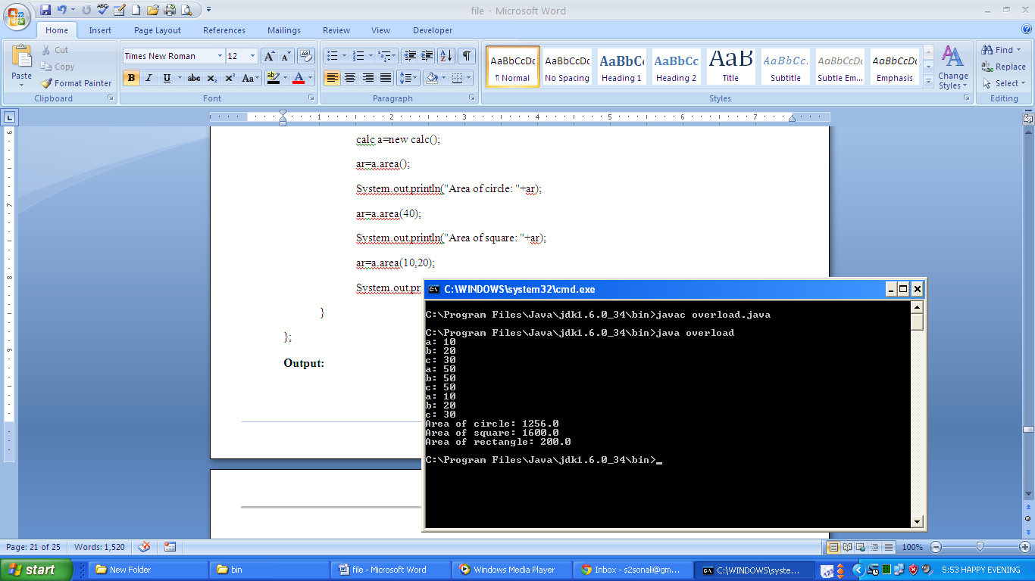

**Q. Write a program to sort the elements of array using insertion sort.**

**Coding:**

import java.lang.*;

class sort

{ public static void main(String arg[])

{ int ar[]=new int[3];

int a,t; ar[0]=9;ar[1]=6;ar[2]=8;

System.out.println("Unsorted Array:");

for(int i=0;i<3;i++)

System.out.print(ar[i]+"\t");

for(int i=1;i<3;i++)

{ a=i;

while(a>0 && ar[a]<ar[a-1])

{ t=ar[a];

ar[a]=ar[a-1];

ar[a-1]=t;

a--; }

}

System.out.println("\nSorted Array:");

for(int i=0;i<3;i++)

System.out.print(ar[i]+"\t"); }

};

**Output:**

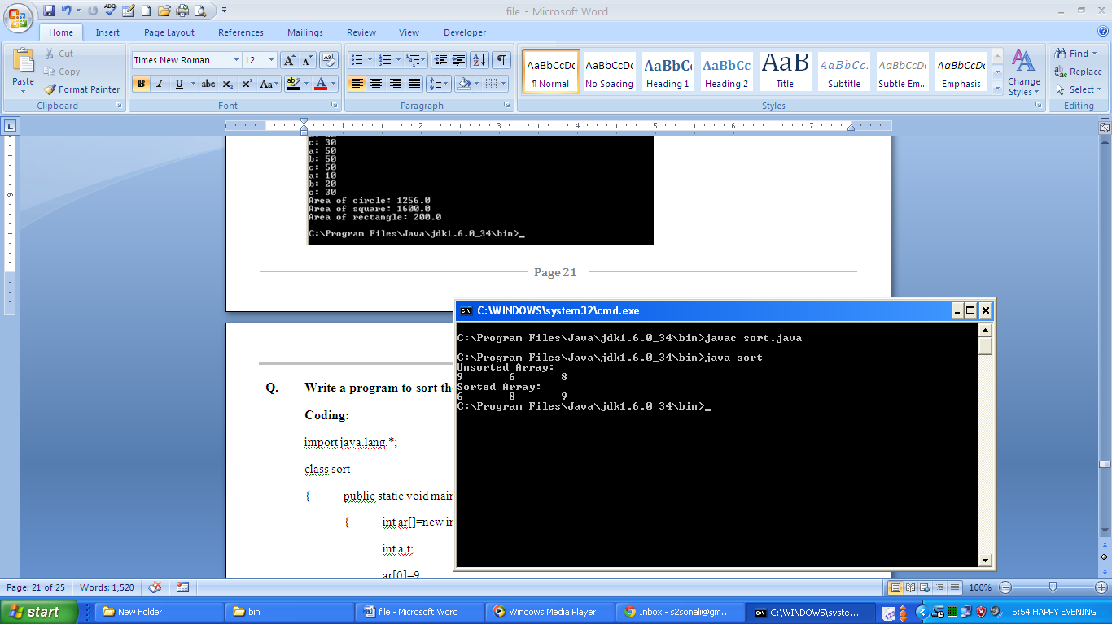

**Q. Write a program to search a given number using binary search.**

**Coding:**

import java.lang.*;

class search

{ public static void main(String arg[])

{ int ar[]=new int[5];

int i=0,l=4,m,a=2,f=0;

ar[0]=1;ar[1]=2;ar[2]=3;

ar[3]=4;ar[4]=5;

while(i<=l)

{ m=(i+l)/2;

if(a==ar[m])

{ f=1; break; }

else if(a<ar[m])

l=m-1;

else

i=m+1; }

if(f==0)

System.out.println("The number is not found.");

else

System.out.println("The number is found.");

}

};

**Ouput:**

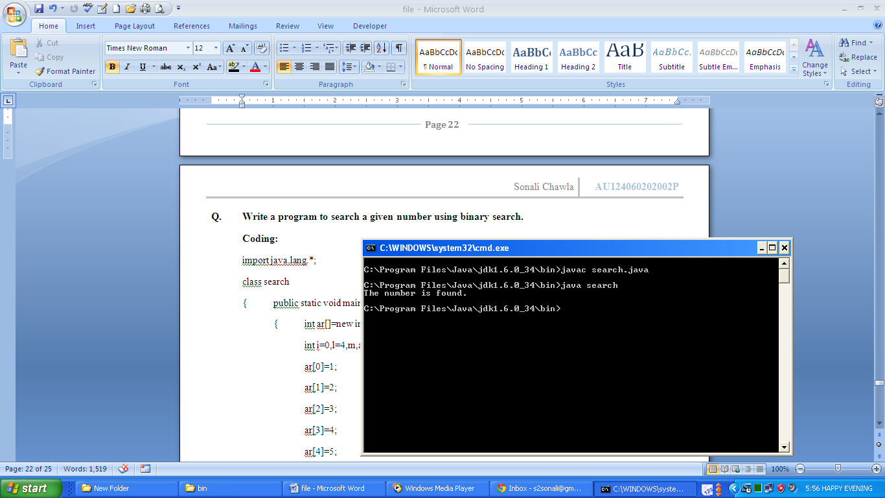

**Q. Write a program to demonstrate the length array members.**

**Coding:**

import java.lang.*;

class length

{

public static void main(String arg[])

{

int a[]={1,2,3,4};

int b[]=new int[5];

System.out.println("Length of Array1: "+a.length);

System.out.println("Length of Array2: "+b.length);

}

};

**Output:**

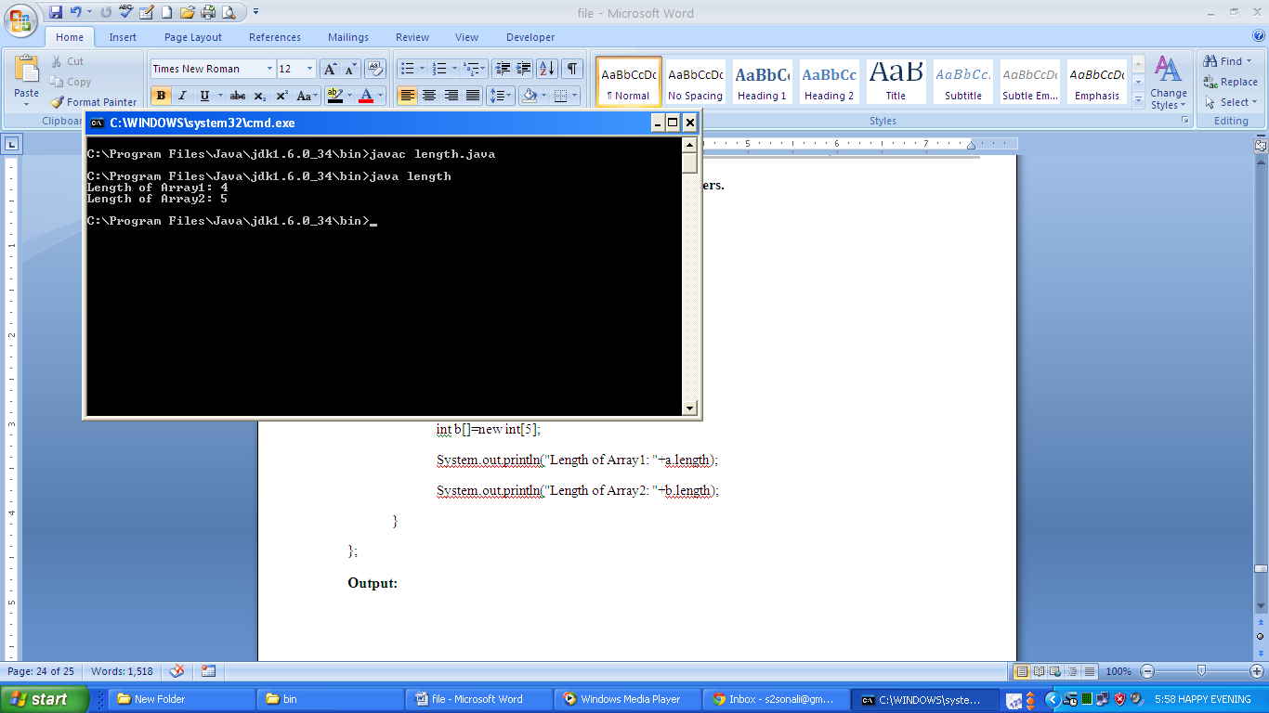

**Q. Write a program to create objects of class String and make use of the inbuilt methods for following:**

* **Length of string**
* **Convert string to uppercase and lowercase**
* **Replace string by another string**
* **Remove whitespaces from the beginning and end of the string**
* **Compare two strings**
* **Check whether a string is equal to other**
* **Find the character at given index**
* **Concat two strings**
* **Find a substring from a given string**

**Coding:**

import java.lang.*;

class strfunc

{

public static void main(String arg[])

{

String s1=new String("Hello");

String s2=new String(" World");

String s3=new String("Bye");

System.out.println("Length of String1:" +s1.length());

System.out.println("Length of String2:" +s2.length());

System.out.println("String1 in Lower Case:" +s1.toLowerCase());

System.out.println("String2 in Upper Case:" +s2.toUpperCase());

System.out.println("String3 replaced:" +s3.replace('y','e'));

System.out.println("String2 after triming:" +s2.trim());

System.out.println("String1 compared to String2:" +s1.compareTo(s2));

if(s1.equals(s2))

System.out.println("String1 matches String2");

else

System.out.println("String1 do not matches String2");

System.out.println("Character at index 3 in String1:" +s1.charAt(3));

System.out.println("Concat of String1 and String2:" +s1.concat(s2));

System.out.println("Substring from String 2:" +s2.substring(2));

System.out.println("Substring from String 2:" +s2.substring(2,4));

}

};

**Output:**

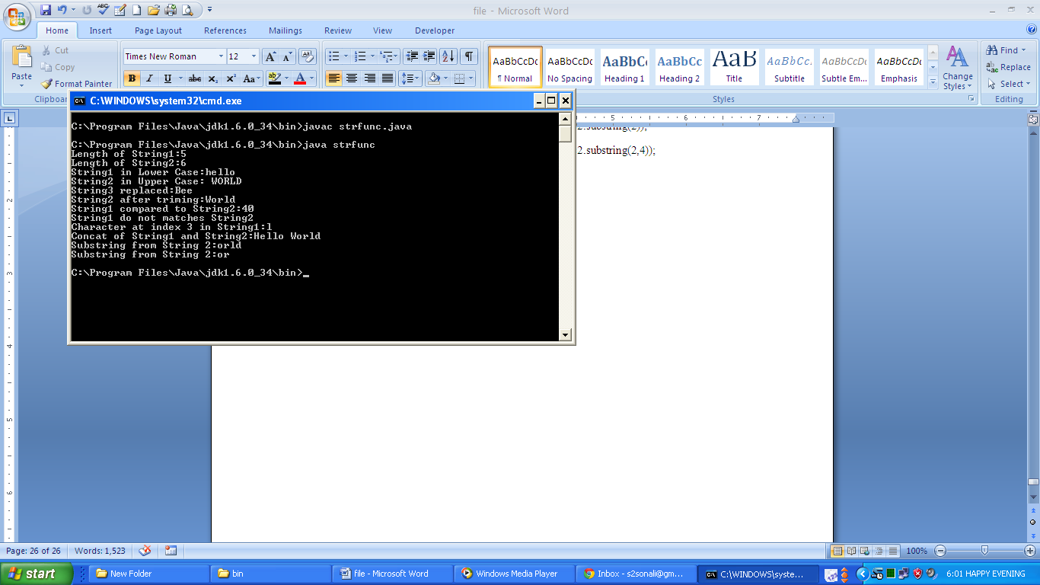

**Q. Write a program to create, access and use the package.**

**Coding:**

//pack.java

package pk;

public class pack

{ public void display()

{ System.out.println("Pack class in Package pk."); }

};

//disp.java

import pk.pack;

class disp

{ public static void main(String arg[])

{ pack p=new pack();

p.display();

}

};

**Output:**

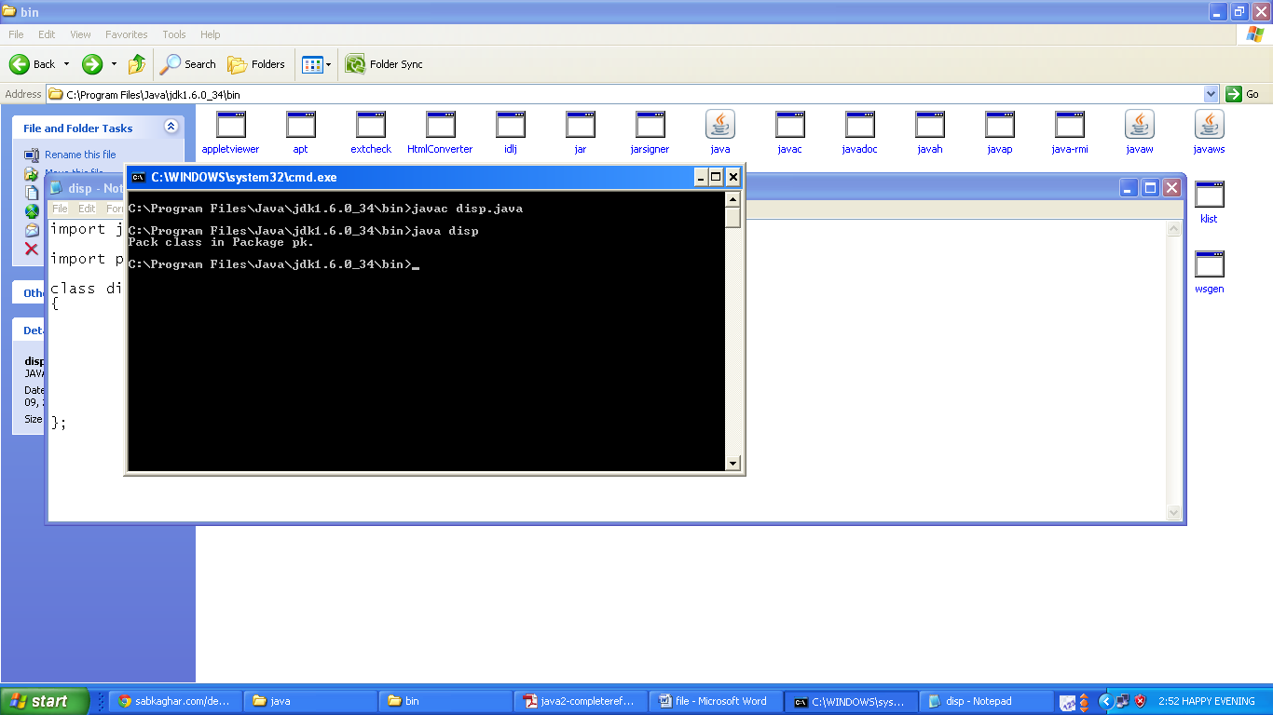

**Q. Write a program to add a class to the package.**

**Coding:**

//pack.java

package pk;

public class pack

{ public void display()

{ System.out.println("Pack class in Package pk."); }

};

//pack1.java

package pk;

public class pack1

{ public void display1()

{ System.out.println("Pack1 class in package pk."); }

};

//disp.java

import pk.*;

class disp

{ public static void main(String arg[])

{ pack p=new pack(); p.display();

pack1 p1=new pack1(); p1.display1(); }

};

**Output:**

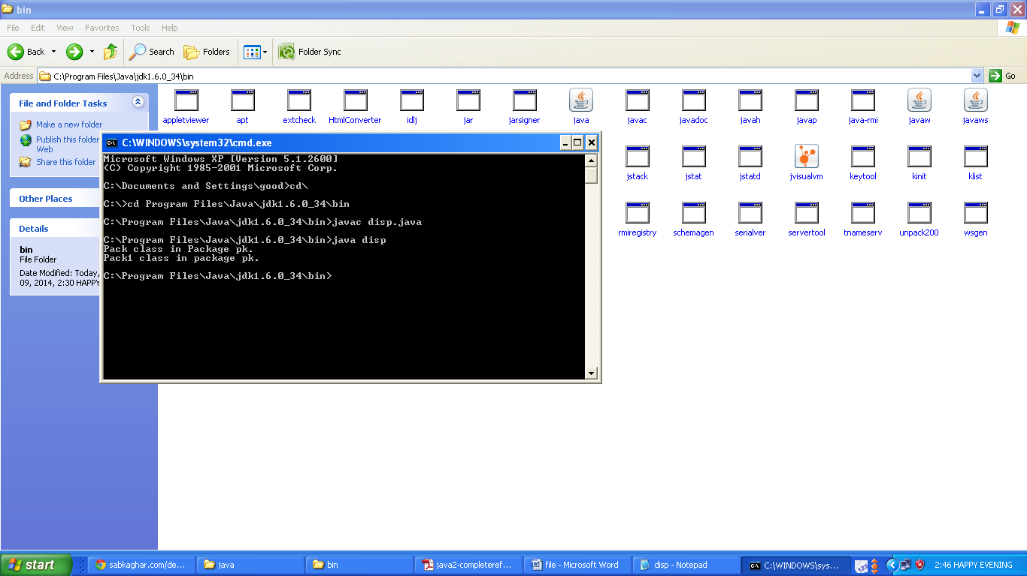

**Q. Write a program to demonstrate use of inheritance through vehicle, two wheeler, three wheeler and four wheeler classes**.

**Coding**:

class vehicle

{ String number, name;

vehicle(String n, String c)

{ number=n; name=c;

System.out.println("\nVehicle Details:");

System.out.println("Number: "+n);

System.out.println("Model Name: "+c);

}

};

class two_wheeler extends vehicle

{ String company;

two_wheeler(String n,String c,String co)

{ super(n,c);

company=co;

System.out.println("Company: "+co);

}

};

class three_wheeler extends vehicle

{ int load;

three_wheeler(String n, String c, int l)

{ super(n,c);

load=l;

System.out.println("Load Carried: "+l);

}

};

class four_wheeler extends vehicle

{ String rc;

four_wheeler(String n, String c, String r)

{ super(n,c);

rc=r;

System.out.println("Registration Certificate: "+r);

}

};

class display

{ public static void main(String arg[])

{ two_wheeler ob=new two_wheeler("HR9CK2015","Activa","Honda");

three_wheeler ob1=new three_wheeler("HR6GH9545","Bajaj RE",500);

four_wheeler ob2=new four_wheeler("DL9CK5728","Swift","AI459562534587U");

}

};

**Output**:

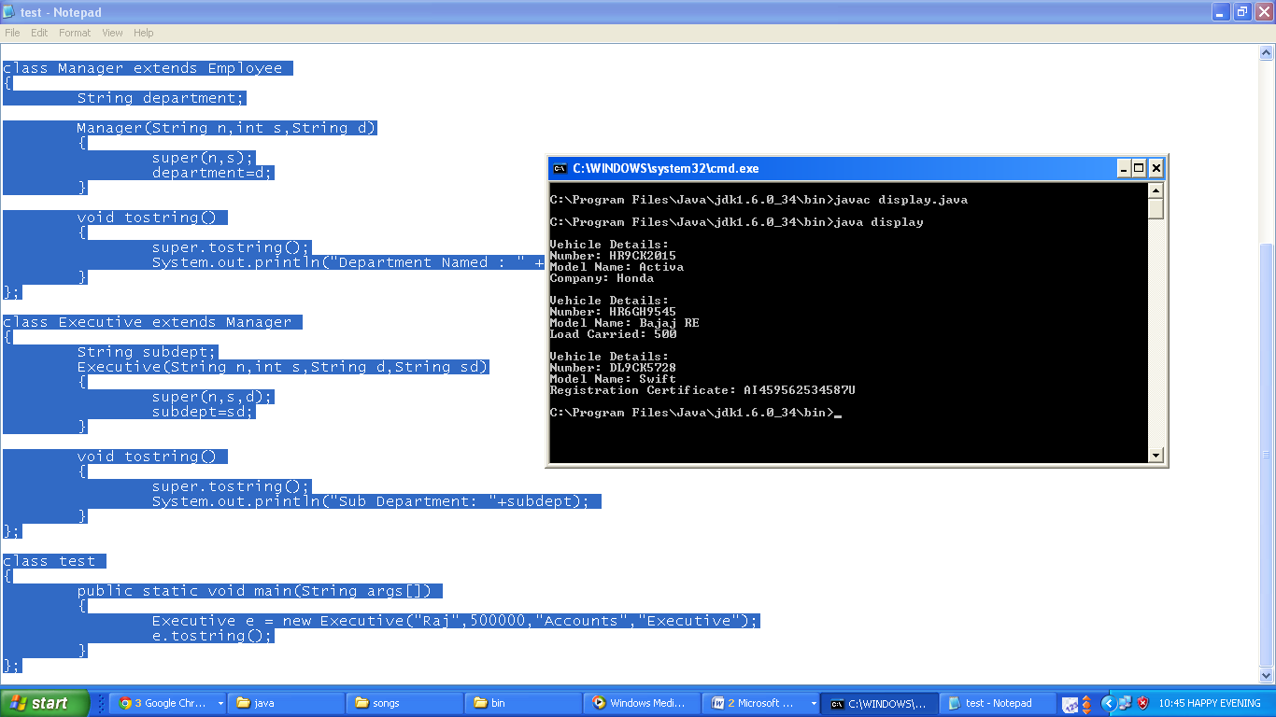

**Q. Write a program to create a class Manager which contains instance variable named department of type String. Supply a method ToString that prints the manager name, department and Salary. Make a class executive inherit from manager. Supply a method ToString that prints the String “Executed” followed by the information stored in the ‘Managers’ super class object. Supply a test program that test these classes and methods.**

**Coding:**

class Employee

{ String name;

int salary;

Employee (String n, int s)

{ name=n;

salary=s;

}

void tostring()

{ System.out.println("Name : " + name + "\nSalary : " + salary); }

};

class Manager extends Employee

{ String department;

Manager(String n,int s,String d)

{ super(n,s);

department=d;

}

void tostring()

{ super.tostring();

System.out.println("Department Named : " + department);

}

};

class Executive extends Manager

{ String subdept;

Executive(String n,int s,String d,String sd)

{ super(n,s,d);

subdept=sd;

}

void tostring()

{ super.tostring();

System.out.println("Sub Department: "+subdept);

}

};

class test

{ public static void main(String args[])

{ Executive e = new Executive("Raj",500000,"Accounts","Executive");

e.tostring();

}

};

**Output:**

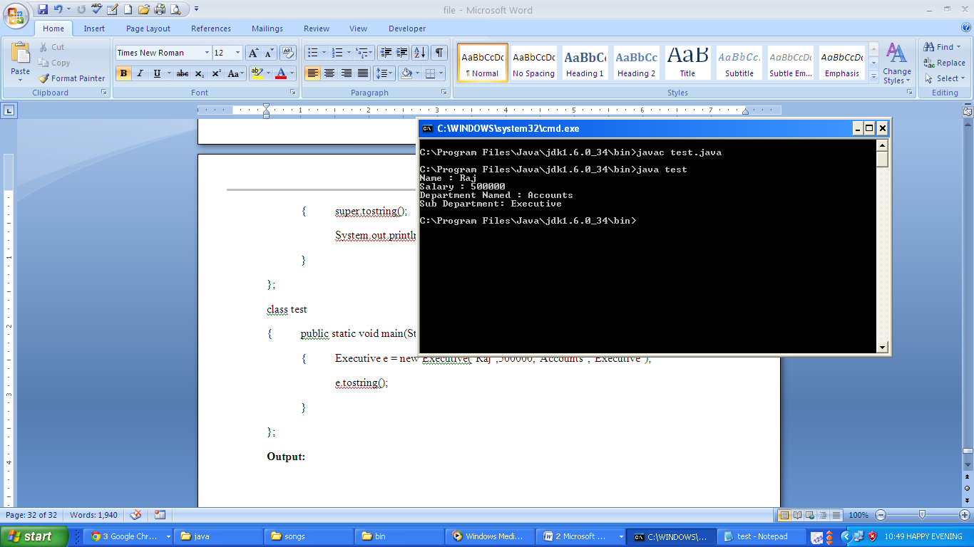

**Q. Write a program to demonstrate run-time polymorphism with the help of abstract classes.**

**Coding:**

abstract class shape

{ int l,b; shape(int x,int y)

{ l=x;b=y; } abstract void area();

};

class rectangle extends shape

{ rectangle(int x,int y)

{ super(x,y); }

void area()

{ System.out.println("Area of rectangle: "+(l*b)); }

};

class triangle extends shape

{ triangle(int x,int y)

{ super(x,y); }

void area()

{ System.out.println("Area of triangle: "+(l*b/2)); }

};

class test

{ public static void main(String arg[])

{ rectangle r=new rectangle(10,50); triangle t=new triangle(10,80);

shape s; s=r; s.area(); s=t; s.area(); }};

**Output:**

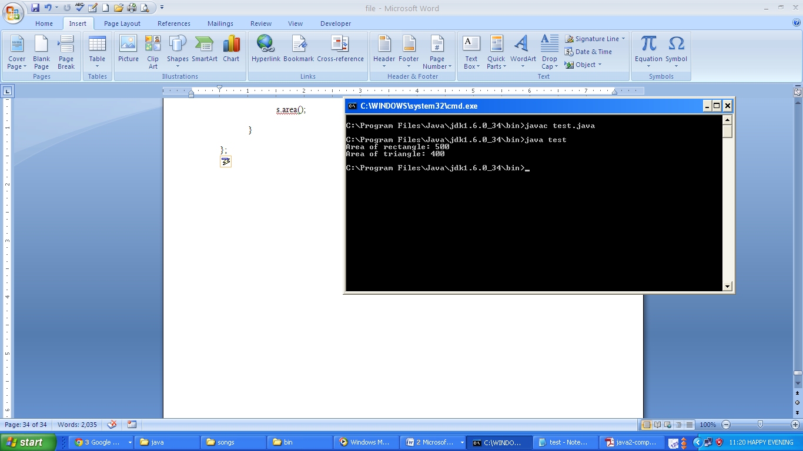

**Q. Write a program to create and run the user defined package math_operation and to import the user defined package into other classes.**

**Coding:**

//arith.java

package math_operation;

public class arith

{ public void add(int a,int b)

{ System.out.println("Sum: "+(a+b)); }

public void sub(int a,int b)

{ System.out.println("Difference: "+(a-b)); }

public void div(int a,int b)

{ System.out.println("Quotient: "+(a/b)); }

public void mul(int a,int b)

{ System.out.println("Product: "+(a*b)); }

};

//cal.java

import math_operation.arith;

class cal

{ public static void main(String arg[])

{ arith a=new arith(); a.add(10,20); a.sub(60,30); a.mul(2,40); a.div(80,4); }

};

**Output:**

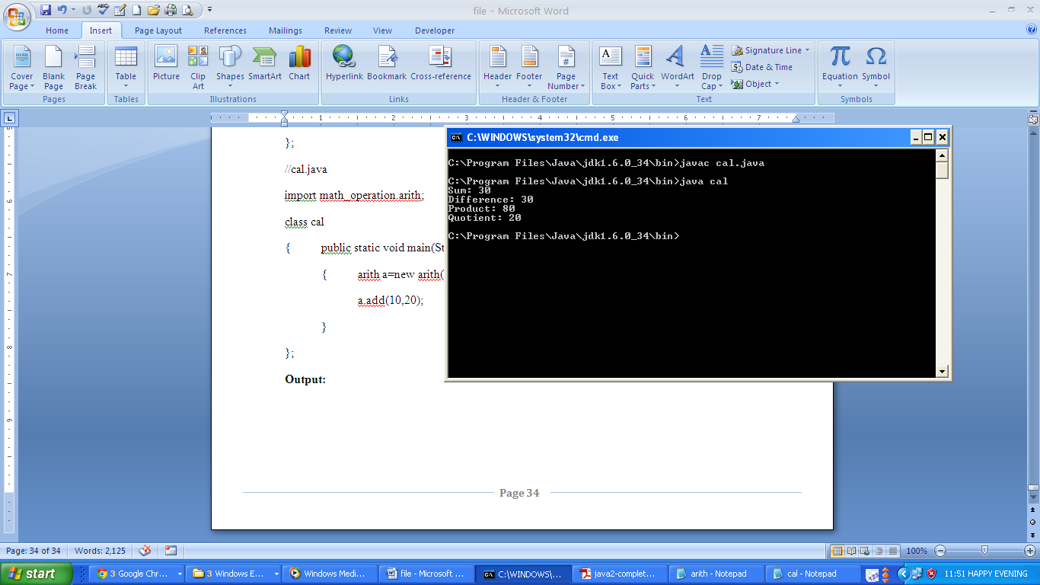

**Q. Write a program to create an object of class StringBuffer using various overloaded constructor and make use of the inbuilt methods for the following:**

* **To find length and capacity of object**
* **To change the length and capacity of object**
* **To set and get a char at the given index**
* **To reverse, replace, insert, append and delete a char at given index**

**Coding:**

class strbfunc

{

public static void main(String arg[])

{

StringBuffer s1=new StringBuffer("Hello");

StringBuffer s2=new StringBuffer();

String s3=new String("Bye");

StringBuffer s4=new StringBuffer(s3);

System.out.println("Length of String1: "+s1.length());

System.out.println("Length of String2: "+s2.length());

System.out.println("Length of String4: "+s4.length());

System.out.println("Capacity of String1: "+s1.capacity());

System.out.println("Capacity of String2: "+s2.capacity());

System.out.println("Capacity of String4: "+s4.capacity());

s1.setLength(6);

s1.ensureCapacity(23);

System.out.println("Length of String1: "+s1.length());

System.out.println("Capacity of String1: "+s1.capacity());

System.out.println("Character at index 0 in String1: "+s1.charAt(0));

s1.setCharAt(0,'C');

System.out.println("After Changing Character at index 0 in String1: "+s1);

System.out.println("Reverse of String1: "+s1.reverse());

s4.replace(0,2,"Hi");

System.out.println("Replace 'By' in String4: "+s4);

s4.deleteCharAt(0);

System.out.println("String4 After Delete of character at index 1: "+s4);

System.out.println("Inserting 'll' in String1: "+s1.insert(2,"ll"));

System.out.println("Appending String4 in String1: "+s1.append(s4));

}

};

**Output:**

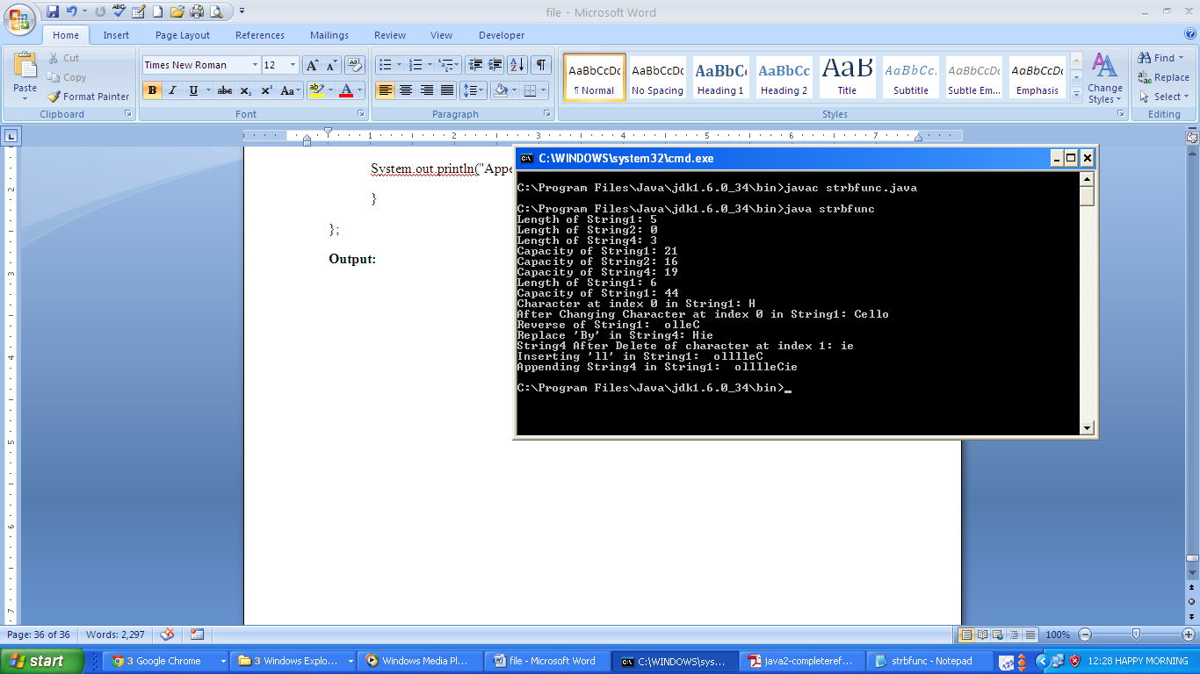

**Q. Write a program to create functions for various operations like addition, subtraction, multiplication and division for accessing elements of an array. Now deliberately insert errors to generate the ArithmaticException and ArrayIndexOutOfBoundsException.**

* **Make use of try catch blocks to catch those exception**

**Coding:**

class exc

{

public static void main(String arg[])

{

int a[]={10,20};

int b[]={0,60};

int c[]=new int[4];

try

{

c[0]=a[0]+b[0];

c[1]=a[1]-b[1];

c[2]=a[0]*b[2];

c[3]=a[1]/b[0];

}

catch(ArithmeticException k)

{

System.out.println("ArithmeticException Caught.");

}

catch(ArrayIndexOutOfBoundsException k)

{

System.out.println("ArrayIndexOutOfBoundsException Caught.");

}

}

};

**Output:**

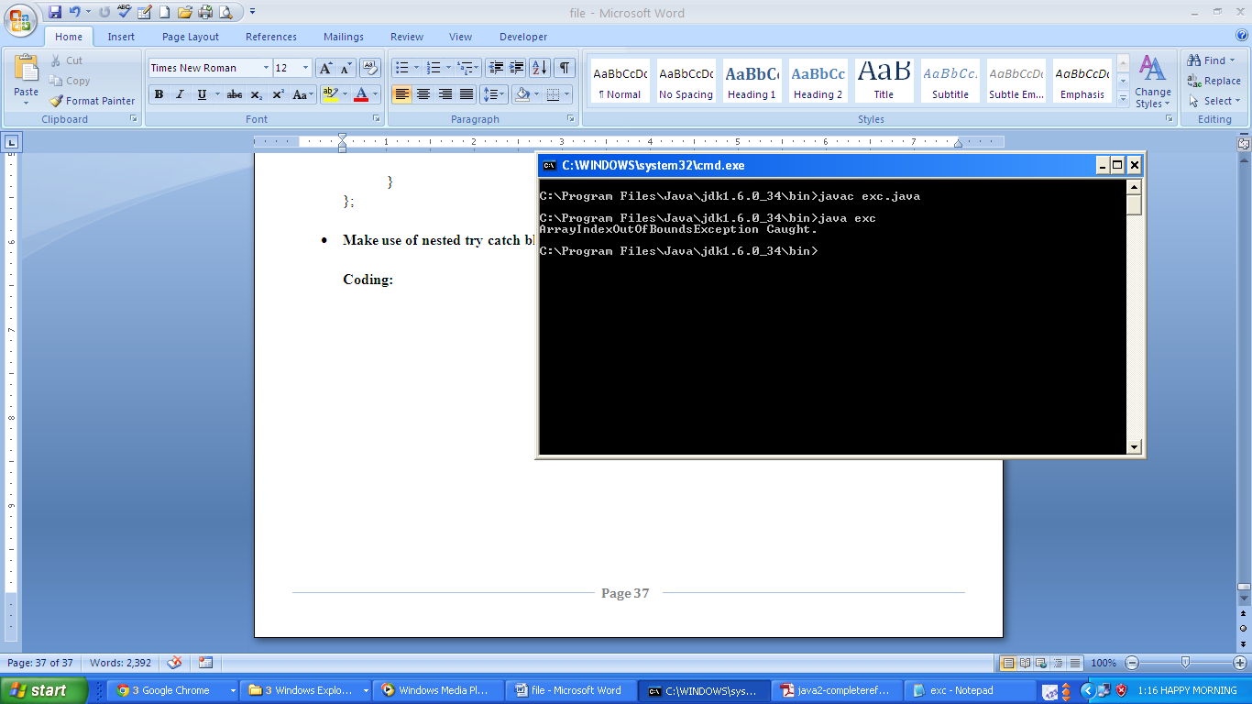

* **Make use of nested try catch block to catch those exception**

**Coding:**

class exc

{

public static void main(String arg[])

{

int a[]={10,20};

int b[]={0,60};

int c[]=new int[4];

try

{

c[0]=a[0]+b[0];

c[1]=a[1]-b[1];

try

{

c[3]=a[1]/b[0];

}

catch(ArithmeticException k)

{

System.out.println("ArithmeticException Caught.");

}

c[2]=a[0]*b[2];

}

catch(ArithmeticException k)

{

System.out.println("ArithmeticException Caught.");

}

catch(ArrayIndexOutOfBoundsException k)

{

System.out.println("ArrayIndexOutOfBoundsException Caught.");

}

}

};

**Output:**

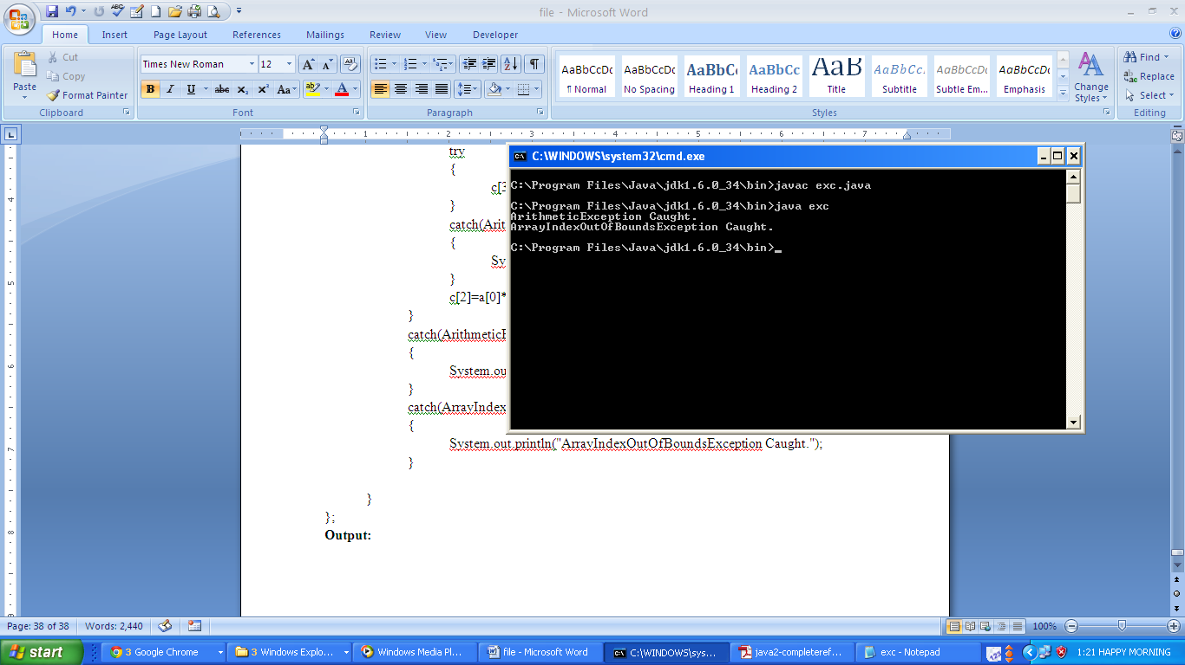

**Q. Write a program to create a thread and to perform the following:**

* **To check if thread is still alive**
* **To change and display name of thread**
* **To change and display priority of thread**
* **To suspend and resume a thread**

**Coding:**

class simple extends Thread

{

int total;

public void run()

{

System.out.println("Thread Starts");

synchronized(this)

{

for(int i=0; i<100 ; i++)

{ total += i; }

notify();

}

}

};

class thrd

{

public static void main(String arg[])

{

simple s=new simple();

System.out.println("Status: "+s.isAlive()); s.start();

System.out.println("Status: "+s.isAlive());

System.out.println("Name: "+s.getName()); s.setName("Thread 1");

System.out.println("Name: "+s.getName());

System.out.println("Priority: "+s.getPriority()); s.setPriority(10);

System.out.println("Priority: "+s.getPriority());

synchronized(s)

{

try

{

System.out.println("Waiting for b to complete...");

s.wait(1);

}

catch(InterruptedException e)

{

e.printStackTrace();

}

System.out.println("Total is: " + s.total);

}

}

};

**Output:**

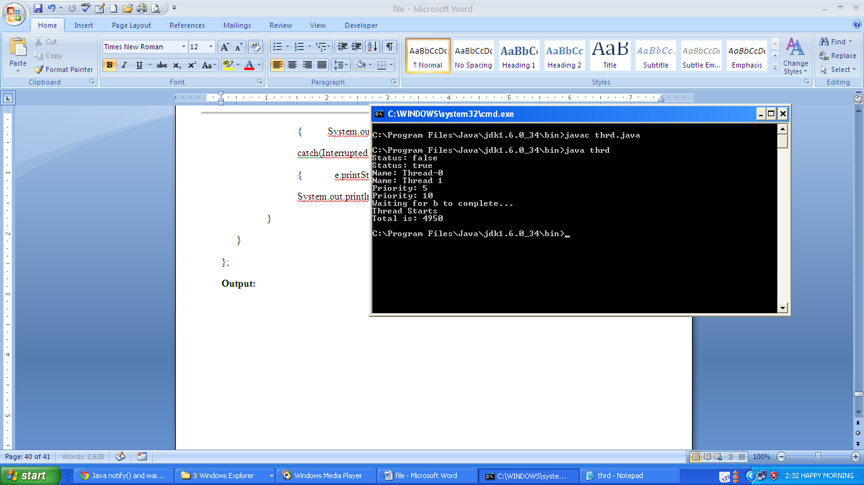

**Q. Write a program to demonstrate read() by reading characters from the console until the user types a *“*q”.**

**Coding:**

import java.io.*;

class b_read

{ public static void main(String args[])throws IOException

{ char c;

BufferedReader br = new BufferedReader(new InputStreamReader(System.in));

System.out.println("Enter characters, 'q' to quit.");

do

{ c = (char) br.read();

System.out.println(c);

} while(c != 'q');

}

};

**Output:**

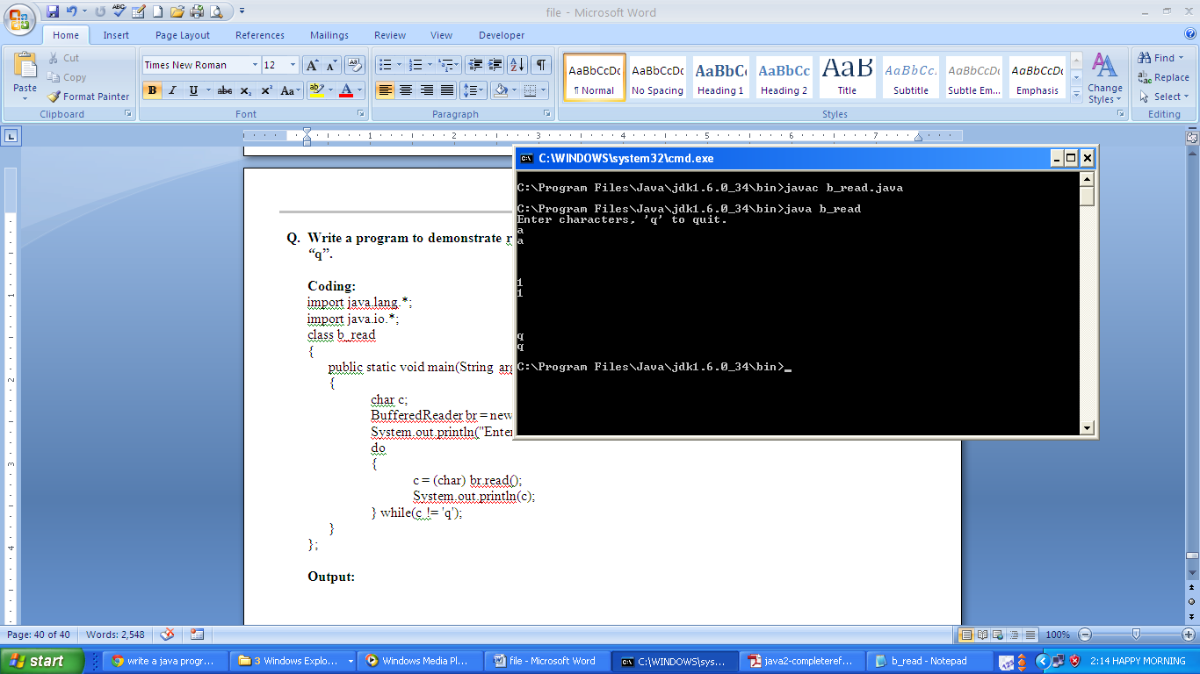

**Q. Write a program to read a string from console using a BufferedReader until user types ‘stop’.**

**Coding:**

import java.io.*;

class bread

{ public static void main(String arg[]) throws IOException

{ BufferedReader br = new BufferedReader(new

InputStreamReader(System.in));

String str;

System.out.println("Enter lines of text.");

System.out.println("Enter 'stop' to quit.");

do

{ str = br.readLine();

System.out.println(str);

} while(!str.equals("stop")); }

}

**Output:**

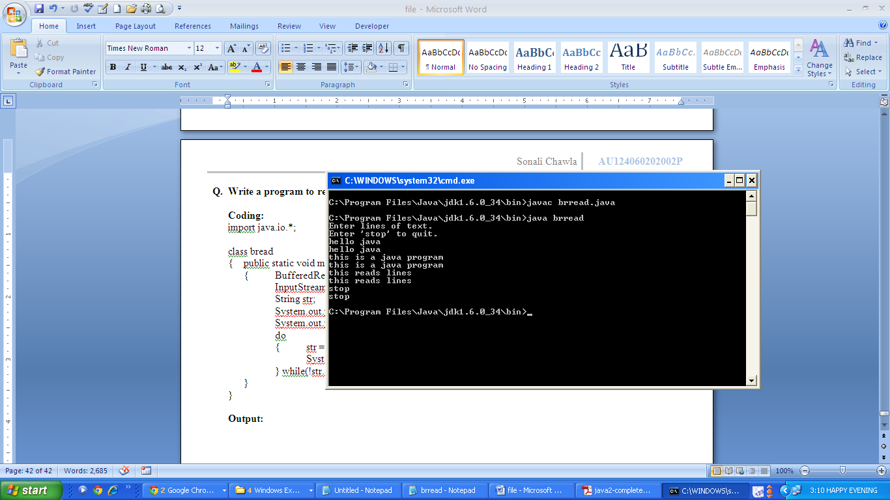

**Q. Write a program to display the following on the webpage using applet:**

**HELLO JAVA**

**Welcome to the World Of Applets**

**Coding:**

//hello.java

import java.applet.*;

import java.awt.*;

public class hello extends Applet

{ public void paint(Graphics gr)

{ gr.drawString("HELLO JAVA",100,110); }

};

//hello.html

<html><head><title>Hello Java</title></head><body>

<h1>Welcome to World Of Java</h1>

<applet code="hello.class" width=200 height=400></applet>

</body></html>

**Output:**

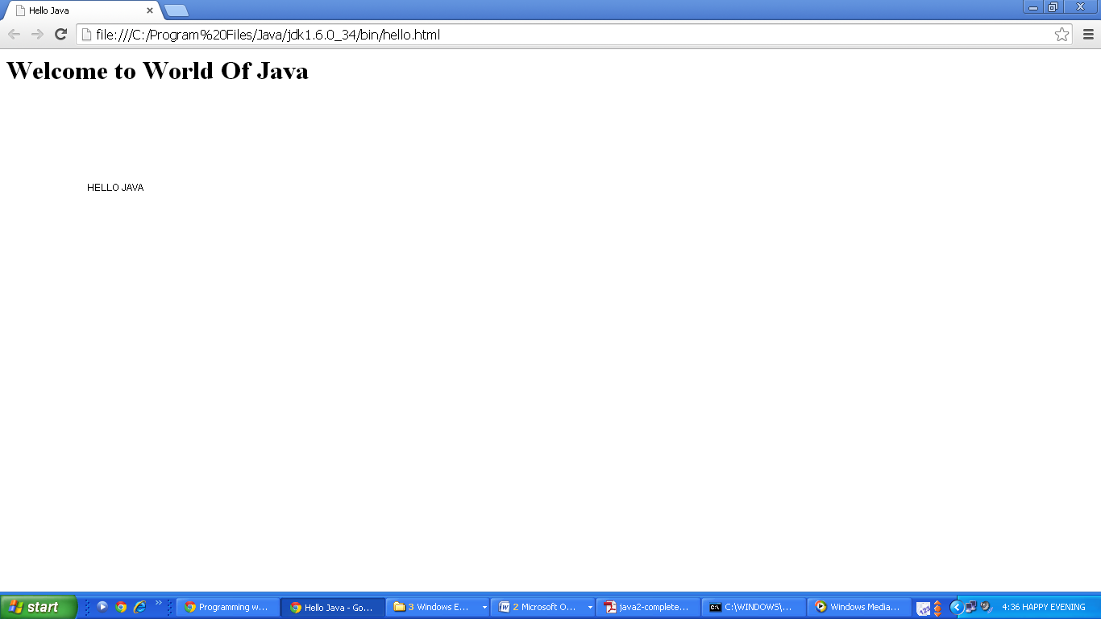

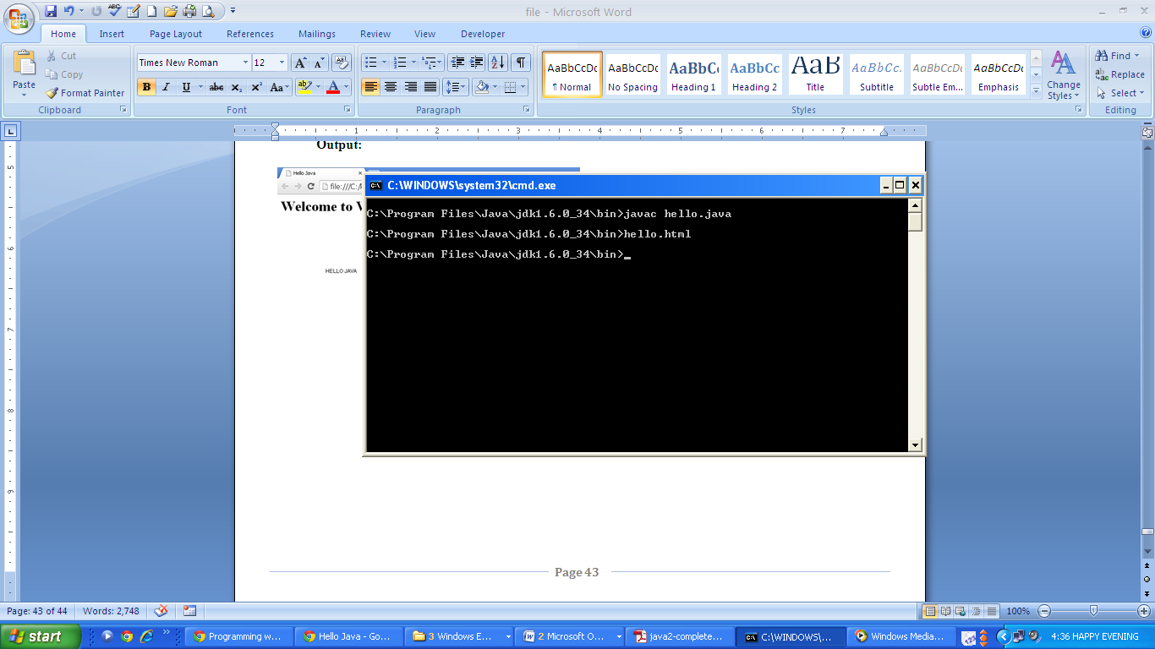

**Q. Write a program to get input from user using applet.**

**Coding:**

import java.awt.*;

import java.applet.*;

/*<applet code="gtinpt.class" width=200 height=400></applet>*/

public class gtinpt extends Applet

{ TextField text1, text2;

public void init()

{ text1=new TextField(8); text2=new TextField(8);

add(text1); add(text2);

text1.setText("0"); text2.setText("0"); }

public void paint(Graphics g)

{ int x=0,y=0,z=0;

String s1,s2,s;

g.drawString("Input a number in each box",10,50);

try

{ s1=text1.getText(); x=Integer.parseInt(s1);

s2=text2.getText(); y=Integer.parseInt(s2);

}catch(Exception ex){}

z=x+y; s=String.valueOf(z);

g.drawString("THE SUM IS: ",10,75);

g.drawString(s,100,75); }

public boolean action(Event event, Object object)

{ repaint(); return true; }

};

**Output:**

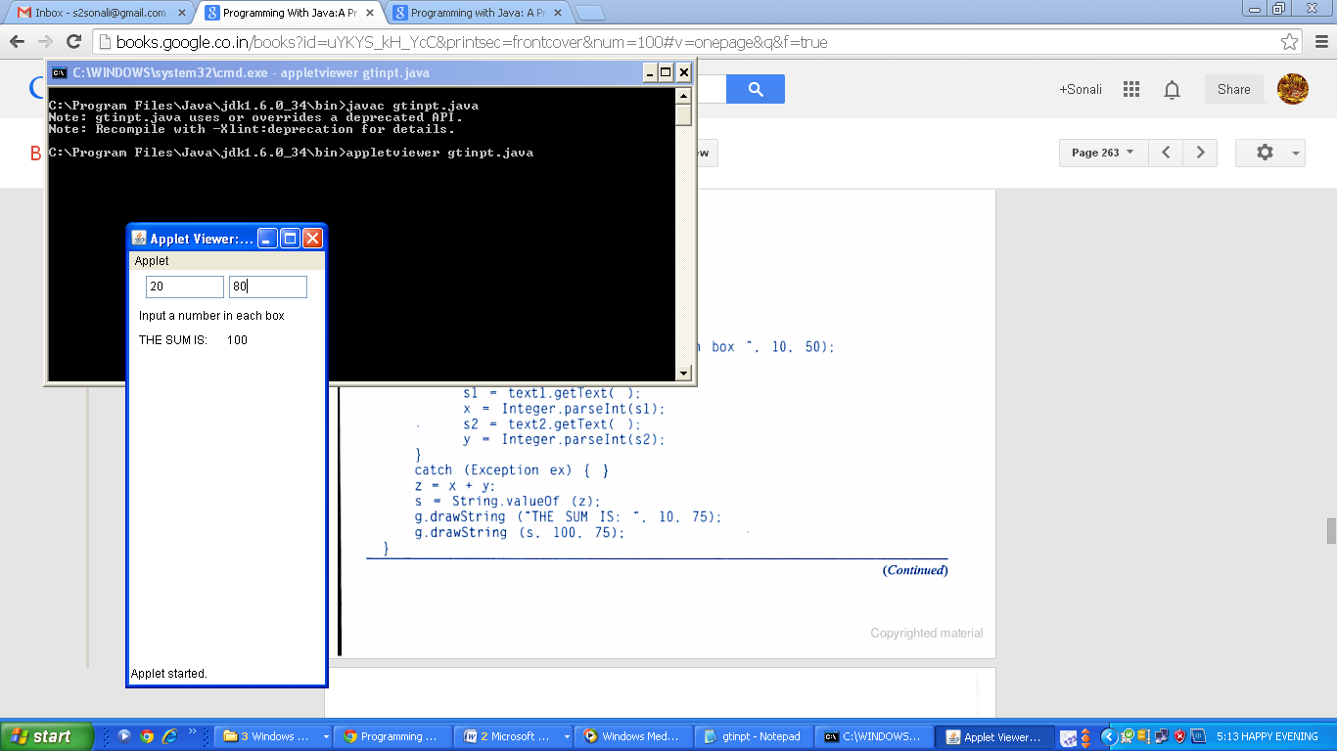

**Q. Write a program to display numeric value in applet using valueOf () method.**

**Coding:**

import java.awt.*;

import java.applet.*;

/*<applet code="numvalue.class" width=300 height=300></applet>*/

public class numvalue extends Applet

{ public void paint(Graphics g)

{ int value1=40;

int value2=60;

int sum=value1+value2;

String str="Sum: "+String.valueOf(sum);

g.drawString(str,100,100);

}

};

**Output:**

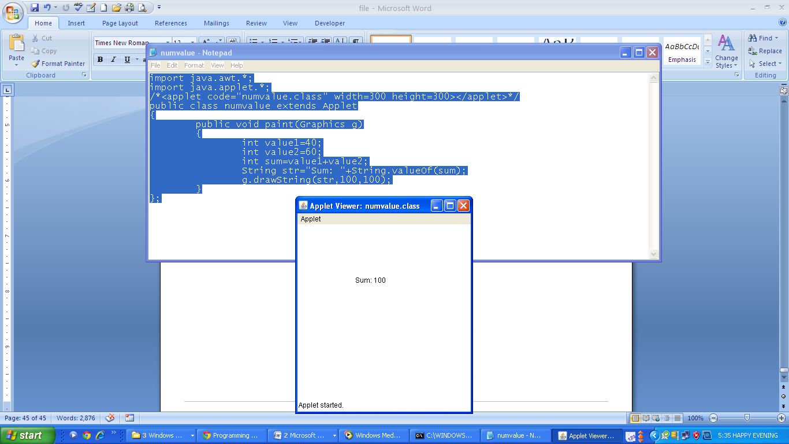

**Q. Write a program to demonstrate the drawing methods of Graphics Class.**

**Coding:**

import java.awt.*;

import java.applet.*;

/*<applet code="graphicsmethd.class" height=100 width=100></applet>*/

public class graphicsmethd extends Applet

{

Font f1=new Font("Times New Roman",Font.BOLD,20);

public void paint(Graphics g)

{

g.setFont(f1);

g.setColor(Color.blue);

g.drawString("Illustration of methods of Graphics Class",100,500);

Font f2=g.getFont();

g.setColor(Color.green);

Color col=g.getColor();

g.fillRect(100,15,70,90);

g.drawRect(200,5,60,60);

g.drawOval(10,120,105,105);

g.setColor(Color.yellow);

g.fillOval(500,140,50,150);

g.setColor(Color.black);

g.drawLine(380,100,200,180);

g.drawArc(400,150,180,280,90,70);

int x2[]={300,120,280,240};

int z2=4,y2[]={260,370,380,170};

g.setColor(Color.blue);

g.fillPolygon(x2,y2,z2);

g.setColor(Color.red);

g.drawRect(15,15,30,50);

FontMetrics f3=g.getFontMetrics();

g.setColor(Color.magenta);

g.fillRoundRect(310,350,90,80,20,20);

}

};

**Output:**

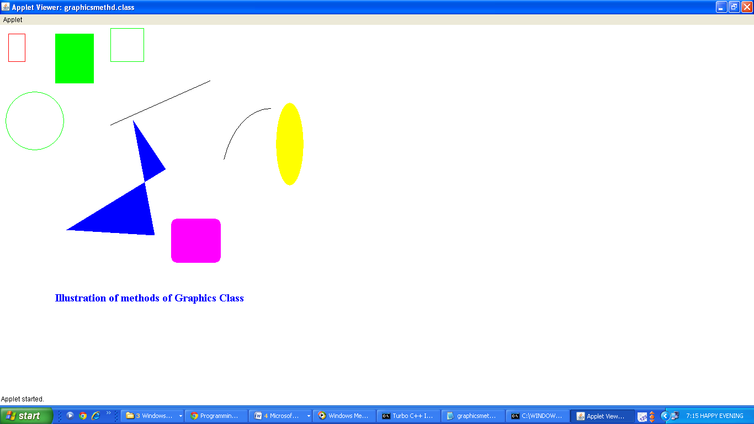

**Q. Write a program to demonstrate the mouse event handlers.**

**Coding:**

import java.awt.*;

import java.awt.event.*;

import java.applet.*;

/*<applet code="mhandle.class" width=300 height=100></applet>*/

public class mhandle extends Applet implements MouseListener, MouseMotionListener

{ String msg="";

int mouseX=0,mouseY=0;

public void init()

{ addMouseListener(this);

addMouseMotionListener(this); }

public void mouseClicked(MouseEvent me)

{ mouseX=0; mouseY=10;

msg="Mouse Clicked."; repaint(); }

public void mouseEntered(MouseEvent me)

{ mouseX=0; mouseY=10;

msg="Mouse Entered."; repaint(); }

public void mouseExited(MouseEvent me)

{ mouseX=0; mouseY=10;

msg="Mouse Exited."; repaint(); }

public void mousePressed(MouseEvent me)

{ mouseX=me.getX(); mouseY=me.getY();

msg="Mouse Down."; repaint(); }

public void mouseReleased(MouseEvent me)

{ mouseX=me.getX(); mouseY=me.getY();

msg="Mouse Up.";

repaint(); }

public void mouseDragged(MouseEvent me)

{ mouseX=me.getX(); mouseY=me.getY();

msg="*";

showStatus("Dragging mouse at "+mouseX+", "+mouseY);

repaint(); }

public void mouseMoved(MouseEvent me)

{ showStatus("Moving mouse at "+me.getX()+", "+me.getY()); }

public void paint(Graphics g)

{ g.drawString(msg,mouseX,mouseY); }

};

**Output:**

